Task 4

1. Chat GPT

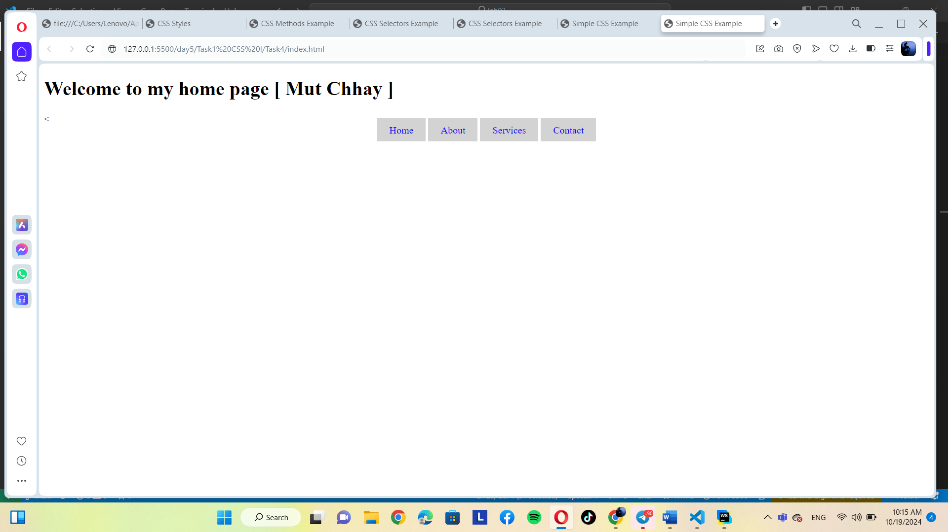2. Gemini is explain but doesn’t send the code